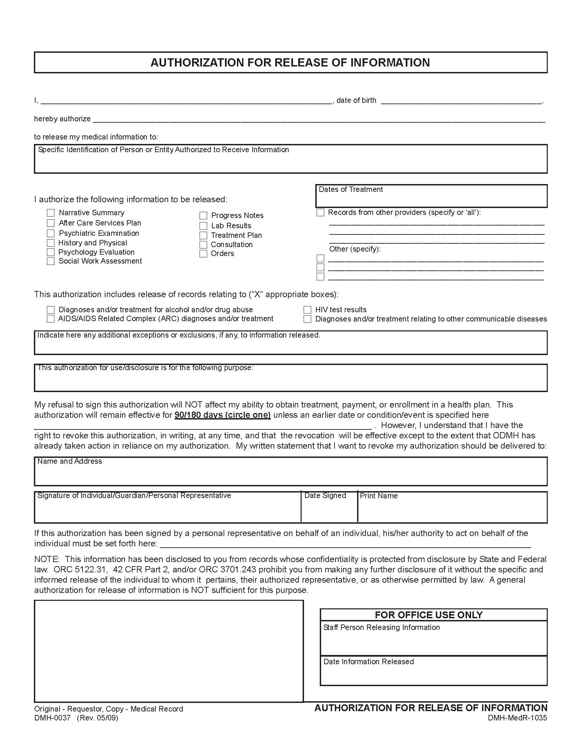
Ronda Jo Corn
06/07/1961
University of Cincinnati
Law Offices of William C. Dearbaugh c/o Axiom Requisition Copy Service, 2869 Jolly Road, Okemos, MI 48864
06/07/1961 to present
X
All

X Medical and Billing Records
Litigation/Claims Discovery
University of Cincinnati, Medical Records, 222 Piedmont Ave Suite 5200, Cincinnati, OH 45219

